­­­­Exp 1

1) create table My_employee(id number(4),last_name varchar(25),first_name varchar(25),userid varchar(25),salary number(9,2));

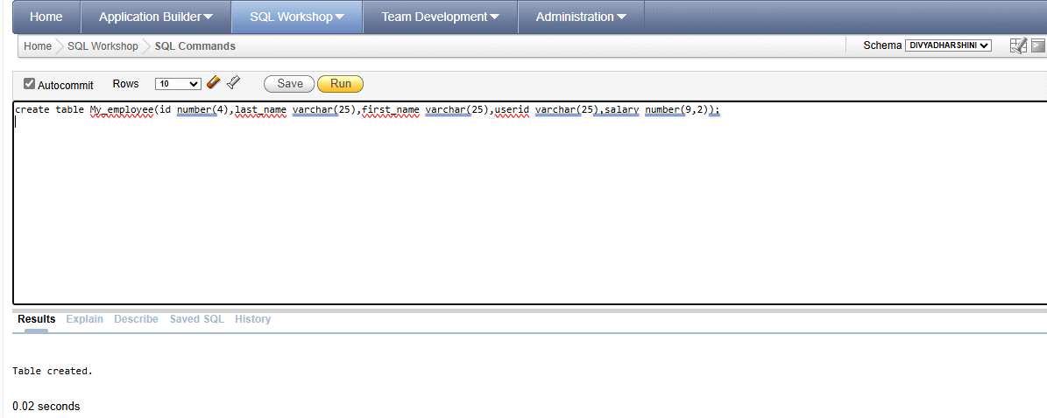

2) begin

insert into my_employee values(1,'Patel','Ralph','rpatel',895);

insert into my_employee values(2,'Dancs','Betty','bdancs',860);

insert into my_employee values(3,'Biri','Ben','bbiri',1100);

insert into my_employee values(4,'Newman','Chad','Cnewman',750);

insert into my_employee values(5,'Ropebur','Audrey','aropebur',1550);

end;

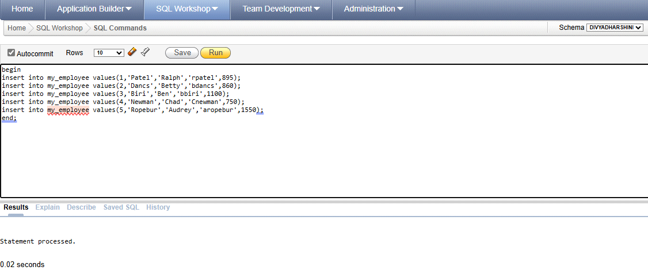

3) select *from my_employee;

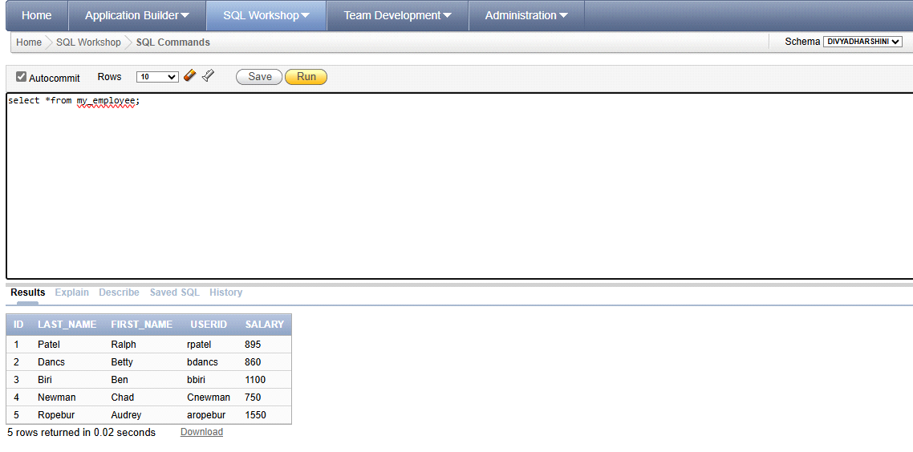

4) update my_employee set userid=lower(substr(first_name,0,1)||last_name);

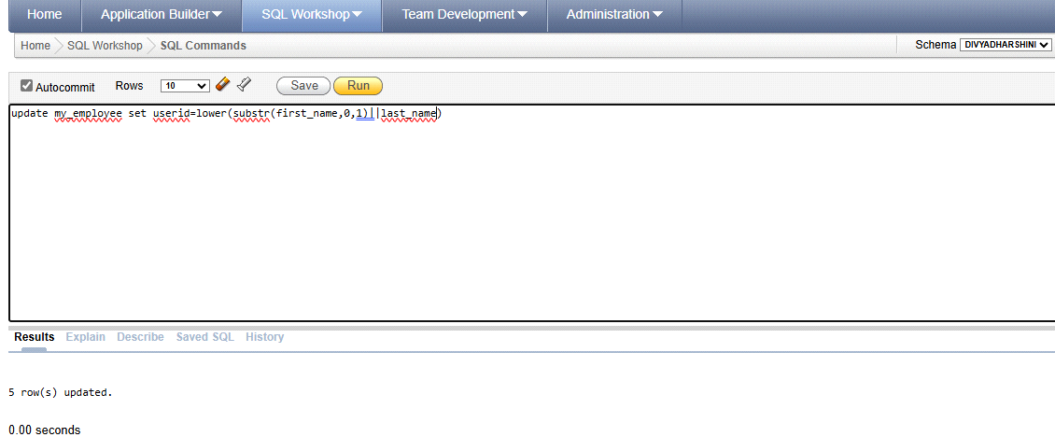

5) delete from my_employee where first_name='Betty';

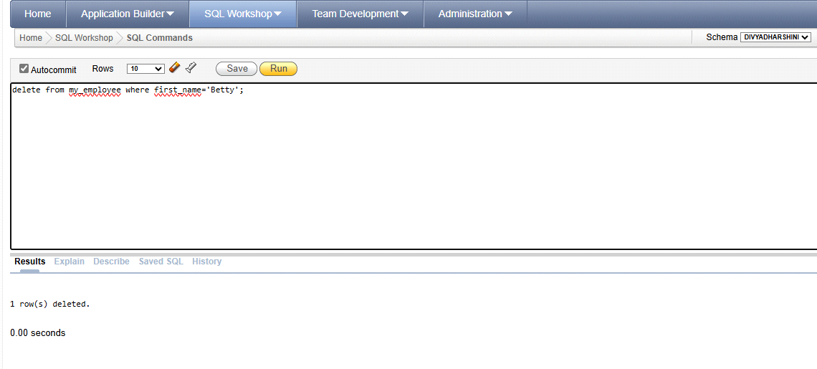

6) update my_employee set userid=NULL,last_name=NULL,first_name=NULL,salary=NULL where id=4;

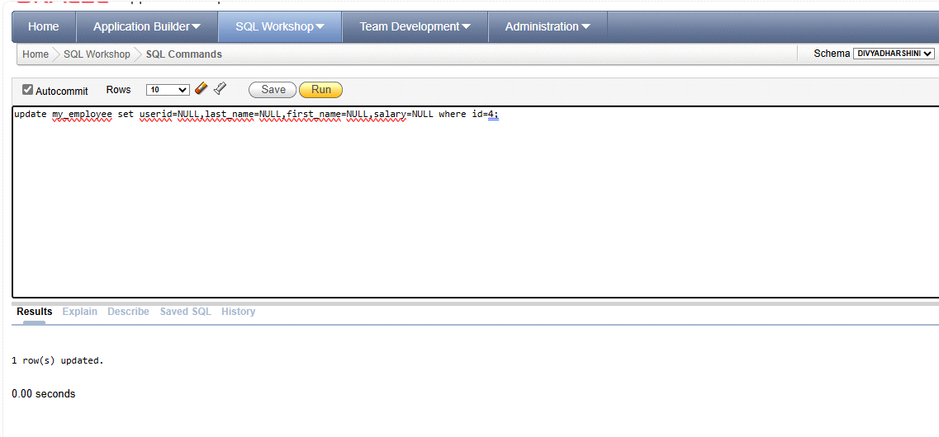

7) commit;

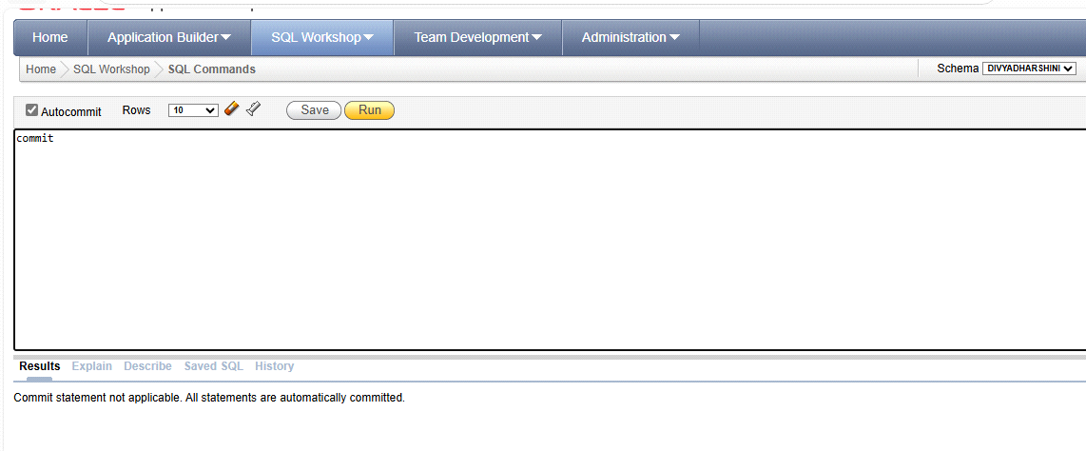

8) update my_employee set last_name='Drexter' where id=3;

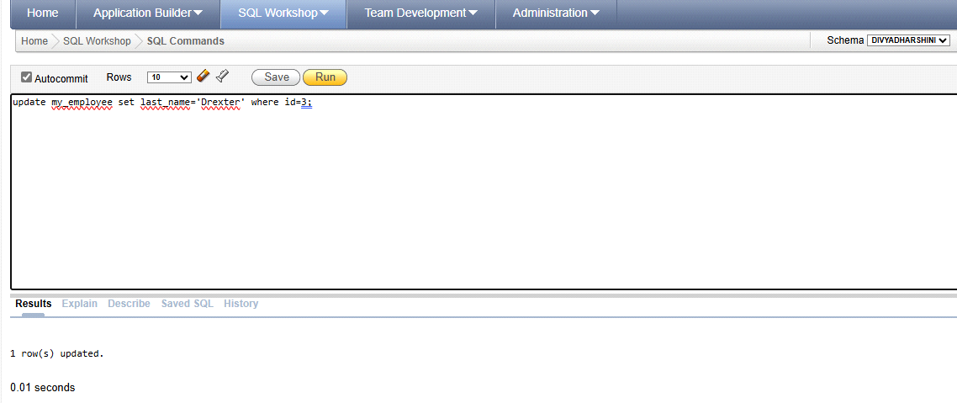

9) update my_employee set salary=1000 where salary<900

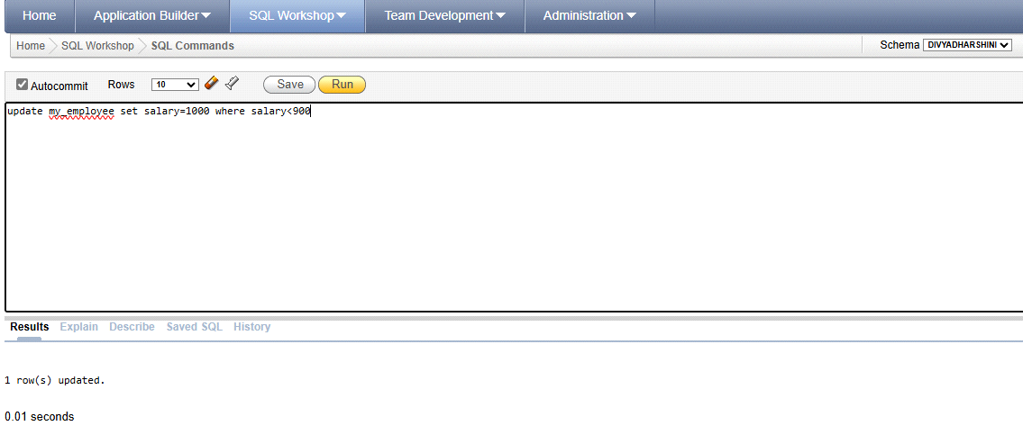

OUTPUT:

